IT 140 Design Document Template
Spencer Reed

Storyboard (Description and Map)
The theme of the game happens inside the “character’s” mind. Each area the player can go represents areas of positive affirmations that further represent ways to overcome the ultimate villain in the game: Imposter Syndrome. The one area that does not support affirmations is the Chamber of Shadows - where Imposter Syndrome resides. The goal is for the player to explore each room and collect the items within them that imprint their respective affirmations onto the player to help defeat Imposter Syndrome. If the player finds the villain before finding all 6 items, they will lose the game; however, they win the game if they collect all 6 items first.

Map of Mind Maze:
Includes: Rooms, items, and villain

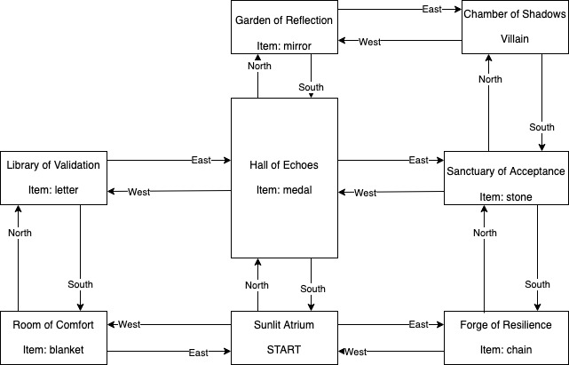

Pseudocode or Flowchart for Code to “Display Current Status”

FUNCTION display_status():

PRINT “You are currently in: {player_position}”

IF player_position is ‘Sunlit Atrium’ OR current room ‘item’ is NONE:

PRINT “This room has no items available”

PRINT “Inventory: {inventory}”

END FUNCTION

END

Pseudocode or Flowchart for Code to “Get Command”

START

FUNCTION get_command(input, player_position, inventory):

INITIALIZE command to input.SPLIT

IF command[0] is “go” AND length GREATER THAN 1:

player_position = CALL move_player(command[1], player_position)

ELIF command[0] is ‘get’ AND length GREATER THAN 1:

inventory = CALL add_to_inventory(command[1] JOIN with spaces, player_position, inventory)

ELIF command[0] is ‘exit’:

PRINT “Exiting game. Thanks for playing!”

CALL exit()

ELSE:

PRINT “Sorry, command not recognized”

RETURN player_position, inventory

END FUNCTION

END

Pseudocode or Flowchart for Code to “Move Between Rooms”

START

FUNCTION move_player(direction, player_position):

IF direction is “North” or “East” or “South” or “West:

IF direction exists in current room:

INITIALIZE player_position to new room in specified direction

PRINT “You have moved to the {“player_position”}”

PRINT Description of room

IF new room contains an item:

PRINT “You see {“item”}”

IF new room contains ‘villain’ key AND ‘villain’ is TRUE:

CALL game_over()

ELSE:
Print “No room in that direction!”

END IF

ELSE:

PRINT: That is not a valid direction

END IF

RETURN player_position

END FUNCTION

Pseudocode or Flowchart for Code to “Get an Item”

START

FUNCTION add_to_inventory(item):

FOR inv_item IN inventory:

IF item in inv_item:

PRINT “You already have the <inv_item>”

RETURN inventory

END FOR

IF ‘item’ in current room is not NONE:

IF ‘item’ exists in current room AND item is a valid item in room:

APPEND item to ‘inventory’

PRINT “ {‘item’} added to inventory!”

PRINT Item description

SET current room ‘item’ key to NONE

CALL check_inventory()

ELSE:

PRINT “That item is not in this room”

CALL display_status()

END IF

ELSE:

PRINT “This room doesn’t have any items available.”

END IF

RETURN inventory

END FUNCTION

FUNCTION check_inventory(inventory):

IF length of inventory is 6:

PRINT “Congratulations! You collected all items needed to defeat Imposter Syndrome!”

CALL EXIT()

END IF

END FUNCTION

Pseudocode or Flowchart for Code for “Game Over”

START

FUNCTION game_over():
PRINT “Game is over”
EXIT()
END FUNCTION

END

Pseudocode or Flowchart for Code “Main Game”

START

FUNCTION main_game():

INITIALIZE player_position to ‘Sunlit Atrium’

INITIALIZE inventory list to EMPTY

INITIALIZE “rooms” as dictionary with Rooms, directions, items, and descriptions

CALL instructions()

PRINT current room description

WHILE True:

CALL display_status(player_position, inventory)

INITIALIZE command to input

ASSIGN player_position AND inventory to CALL get_command(command, player_position, inventory)

END WHILE

END FUNCTION

END

